Nicholas Sammut

CSC 425 – Mobile Computing

Dr. Mark Allison

InClass Lab

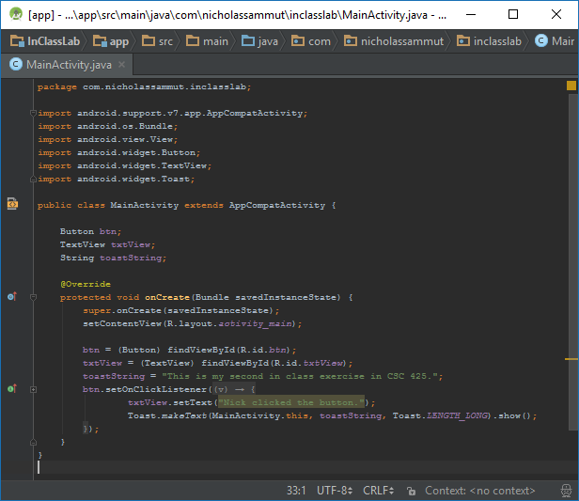

MainActivity.java

Before After

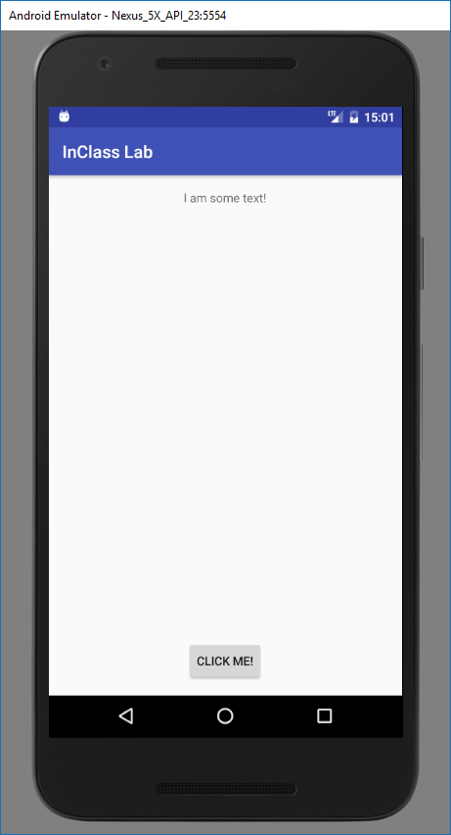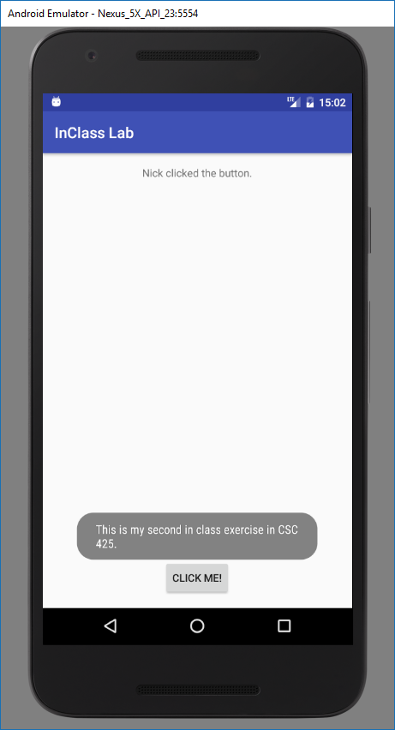

Screenshots of Activity